1. Which are the top three variables in your model which contribute most towards the probability of a lead getting converted?

**Answer:** Top three variables which contribute most to the lead conversion are ‘TotalVisits’ , ‘Total Time Spent on Website’ , ‘Page Views Per Visit’ as these three variables shows maximum variance with the output variable.

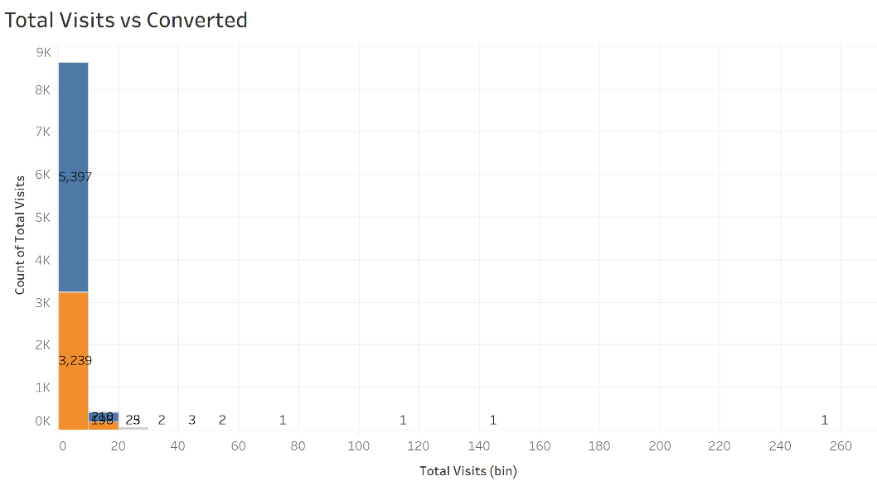

As per above graph total visits between 0-20 shows maximum variance among potential convertible leads.

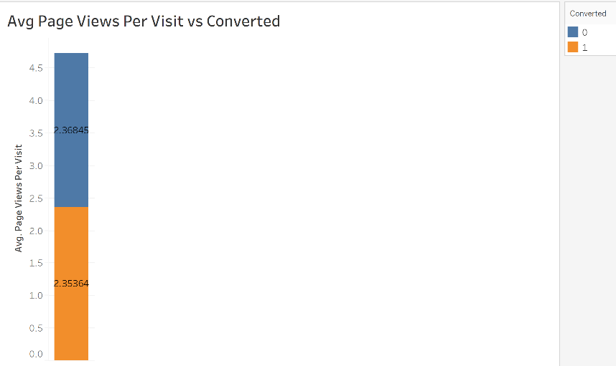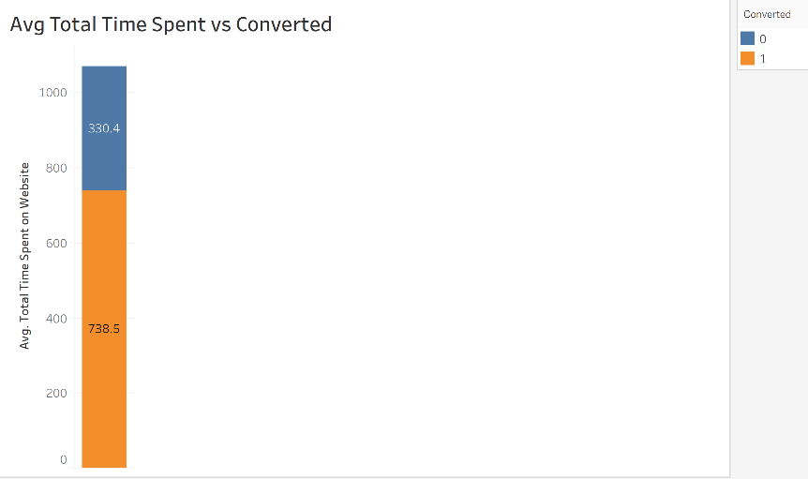

As per above two graphs its clearly visible that Total Time spent on website shows 70% of the potential leads who are spending more time are likely to be convertible to 1.

Also Page Views per Visit shows 50-50 distribution among potential which are likely to be convertible or not.

1. What are the top 3 categorical/dummy variables in the model which should be focused the most on in order to increase the probability of lead conversion?

**Answer :**

* 1. Last Notable Activity Had a Phone Conversation shows increased probability for successful conversion of a lead.

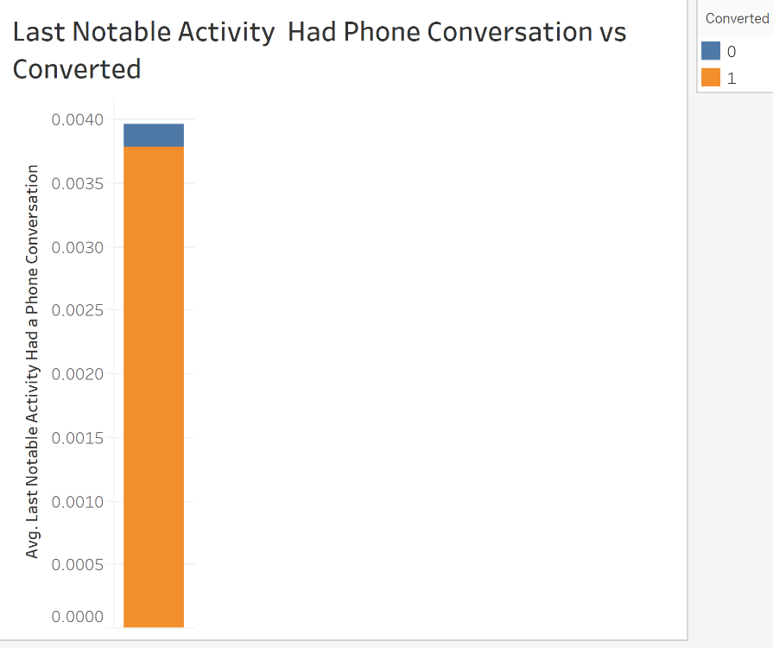

* 1. Last Notable Activity resubscribed to Emails

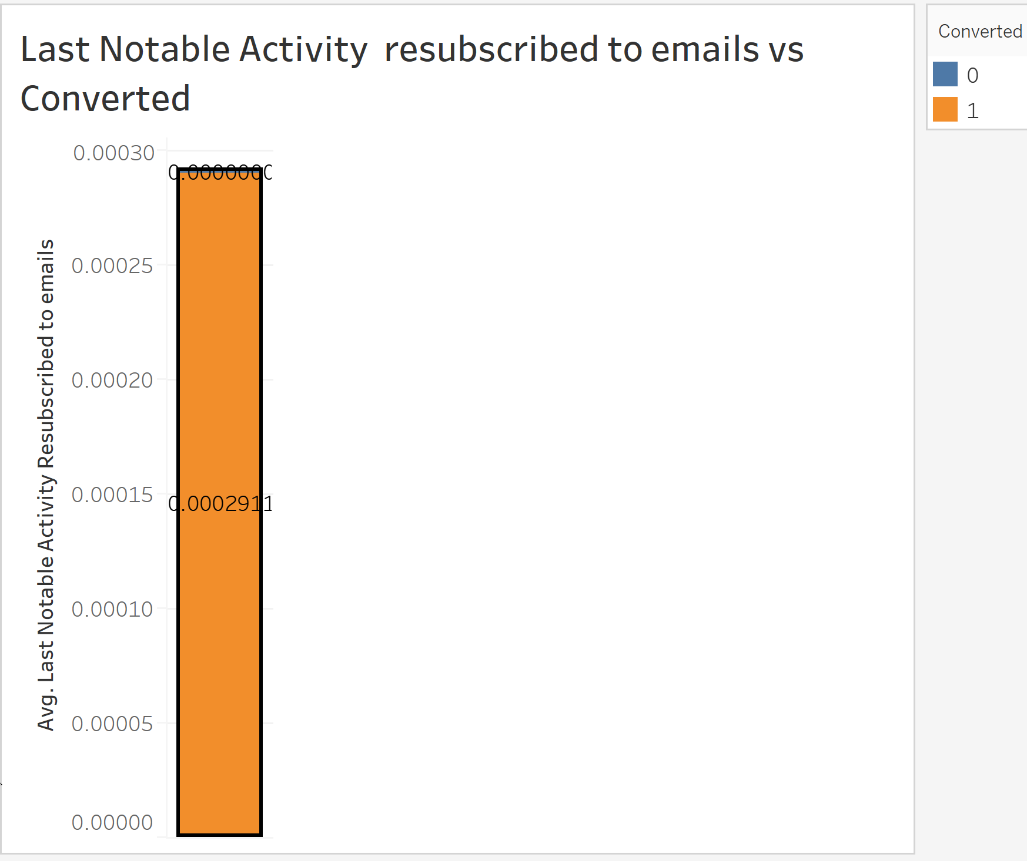

* 1. Last Notable Acivity SMS Sent

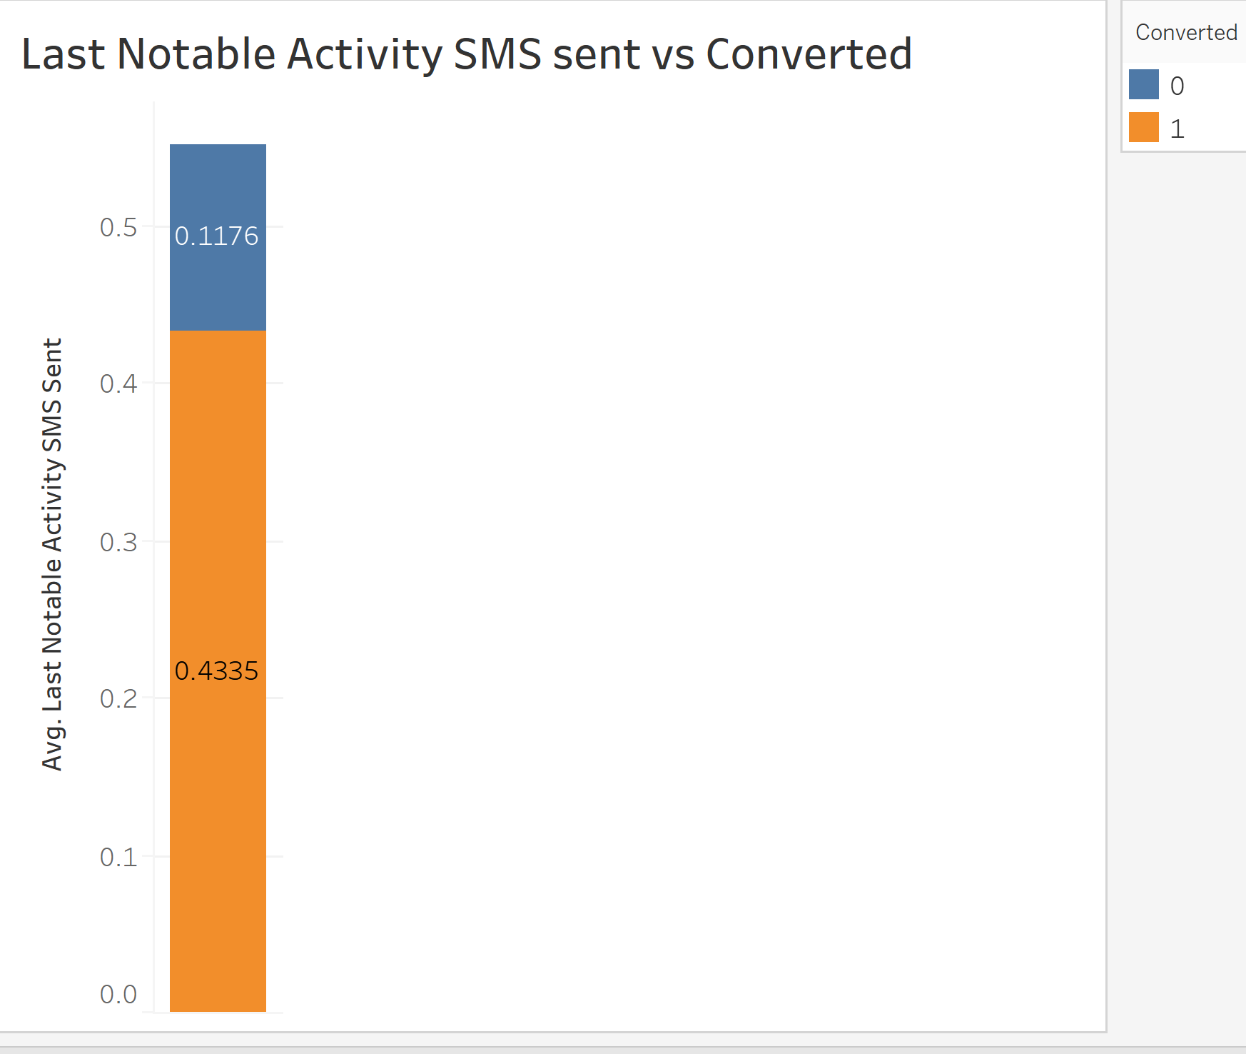

1. Education has a period of 2 months every year during which they hire some interns. The sales team, in particular, has around 10 interns allotted to them. So during this phase, they wish to make the lead conversion more aggressive. So they want almost all of the potential leads (i.e. the customers who have been predicted as 1 by the model) to be converted and hence, want to make phone calls to as much of such people as possible. Suggest a good strategy they should employ at this stage.

**Answer :** As per results predicted by our model the number of potential leads which are likely to convert (1) are close to 3500 out of 9000.

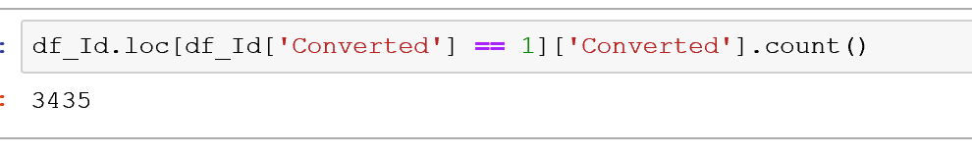

Hence in order to make phone calls to 3500 customers , they should be divided among 10 sales interns over a period of 60 days.

Around 350 customers should be given to each intern , these intern have a duration of 60 days to engage these potential leads into effective phone conversations and convert them into permanent lead by end of this duration.

1. Similarly, at times, the company reaches its target for a quarter before the deadline. During this time, the company wants the sales team to focus on some new work as well. So during this time, the company’s aim is to not make phone calls unless it’s extremely necessary, i.e. they want to minimize the rate of useless phone calls. Suggest a strategy they should employ at this stage.

**Answer :** While having a conversation with any potential lead an intern should regularly note down the behavior of conversation happening between them (going in positive or negative direction) , this would help them judge whether customer is likely to convert or not. Conversation can be judged on various parameters as below.

a.Relevance of questions asked

b.How curious customer is to gather information about course.

c.Is Customer tending towards completing the registration.

Based on the analysis done for each customer an intern can reduce/eliminate the no of calls to the leads who are unlikely to convert positively.